PUBLIC VERSION

June 04, 2012

Ms. Kim Glas, Chair person.
Committee for the Implementation of Textile Agreements
U.S. Department of Commerce (CITA)
14th Street & Constitution Avenue, N.W.
Room H3001A
Washington, D.C.20230

Re: Request under the commercial Availability Provision of the Dominican Republic-Central
America-United States Free Trade Agreement Implementation Act

Seamless Knit Fabrics of Nylon/Spandex
Classifiable Under HTS Subheading 61 17 90 00

Dear Ms. Glas

On behalf of ATA Seamless Textiles Dominicana S.R.L., Dominican Republic, and pursuant to the provisions of Section 203(0)(4) of the Dominican Republic-Central American-United States Free Trade Agreement (" DR-CAFTA") Implementation Act ("the Act") and the Federal Register Notice of February 21, 2006 published by the Committee for the Implementation of Textile Agreements, We submit this request regarding a modification to the list of fabrics, yarn and fibers not available in commercial quantities in a timely manner in the countries of the DR-CAFTA, therefore request that the subject fabrics be placed on the list in Annex 3.25 of the Agreement.

DETAILED PRODUCT INFORMATION

The fabric in question is seamless knit fabrics. The yarn is textured continuous filaments 2 plied micro nylon 6.6 .Complete fabric specification as follows:

Fabric Type: Seamless Knit Fabrics. Knitting type single jersey basic for seamless products.
Fiber Content : 80% to 90% Nylon / 10% to 20% Spandex.
Yarn Count: 44/34x2 (44 Decitex-34 continuous filaments 2 plied micro nylon textured yarns)
88 Decitex-80 Denier final count semi dull.
Gauge: 12 to 17
Weight: 150 to 400 grams per square meter.
Width: 25 to 50 centimeters (10 to 20 inches)
Length: 10 to 120 centimeters (4 to 47 inches)
Finish: (Piece) dyed, printed.

The Honorable, Ms. Glas
June 04, 2012
Page 2

QUANTITY

ATA Seamless Textiles requires 60,000. Pounds, (27.215 kgs) of the subject fabrics each month to be delivered to its facilities that are going to be used in Dominic Republic for the production and subsequently exportation to the United States as intimate apparel finished good.

DUE DILIGENCE

We have contacted the three associations representing the U.S. textile industry and neither they nor any of their members has communicated to us any interest in supplying the subject fabrics. We also send inquires to the national associations representing the textile industries of Costa Rica, Dominic Republic, El Salvador, Guatemala, Honduras and Nicaragua, and did not received any feedback manifesting their interest in supplying the subject fabrics. We have also contacted some textile mills who produce knitted fabrics in the DR-CAFTA region. None has indicated an ability to or interest in supplying these fabrics. Finally we have contacted Hanesbrands, Inc. the seamless fabric producers and seamless wear manufacturer in the market. They were also not interested in supplying these fabrics.

The information below specifies the associations and firms that were contacted with regard to whether they could make the subject fabrics described above. The business confidential documentary confirmations of the contacts are provided with the confidential version of our submission . All communications were done via email.

The following table lists all trade associations and CAFTA-DR producers which we sent request letters. The second column of the table describes any responses received, where not response were received, the third column of table describes subsequent attempts to contact potential suppliers via email.
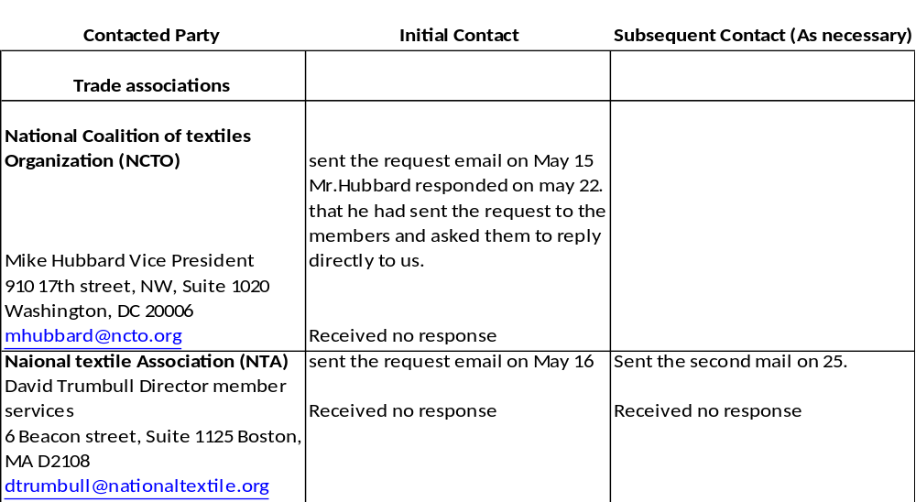
The Honorable, Ms. Glas
June 04, 2012
Page 3

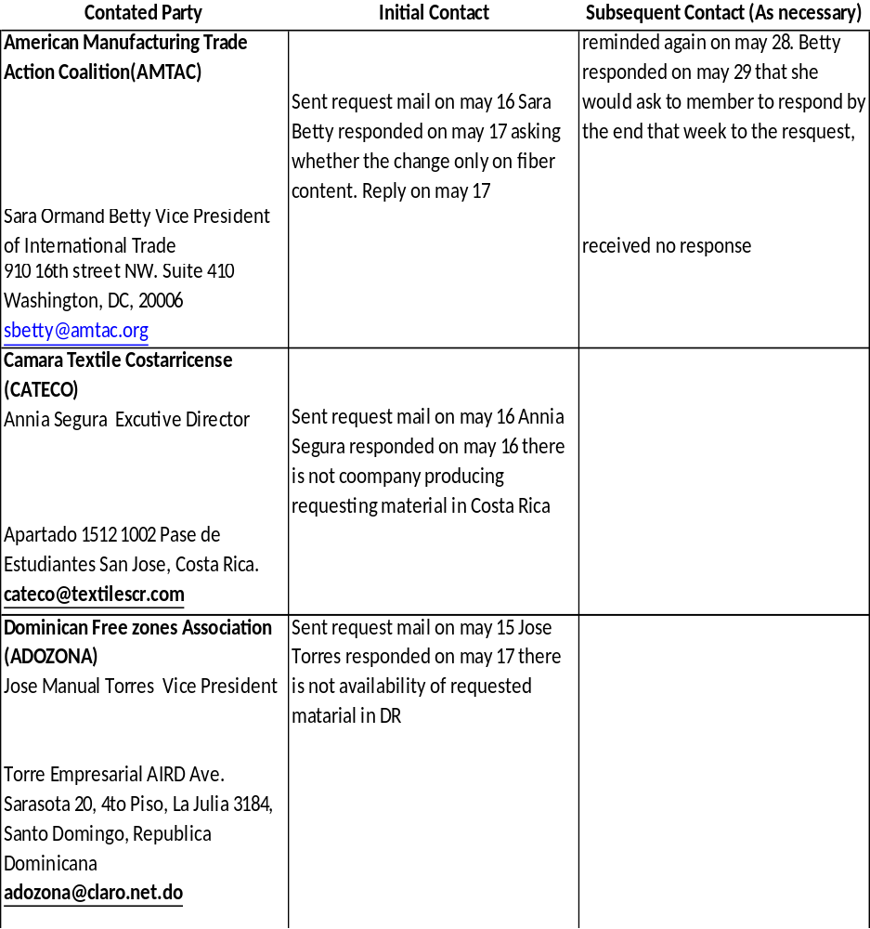

The Honorable, Ms. Glas
June 04, 2012
Page 4

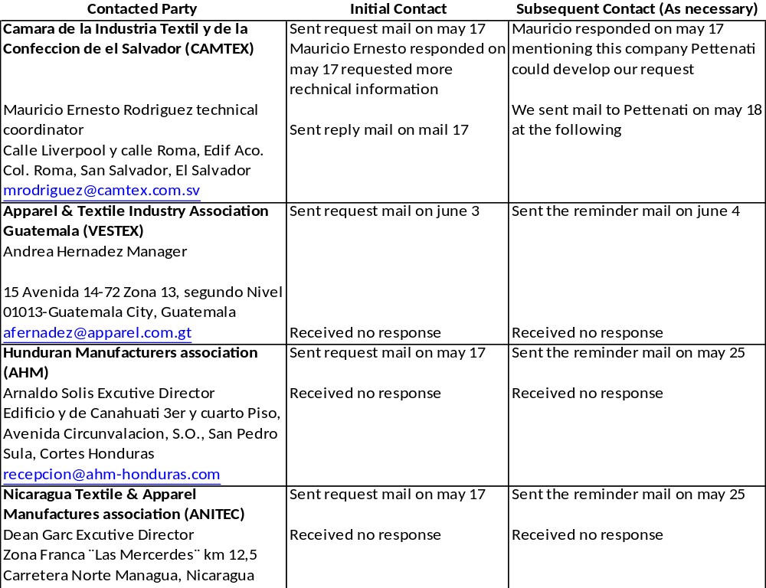

The Honorable, Ms. Glas
June 04, 2012
Page 5

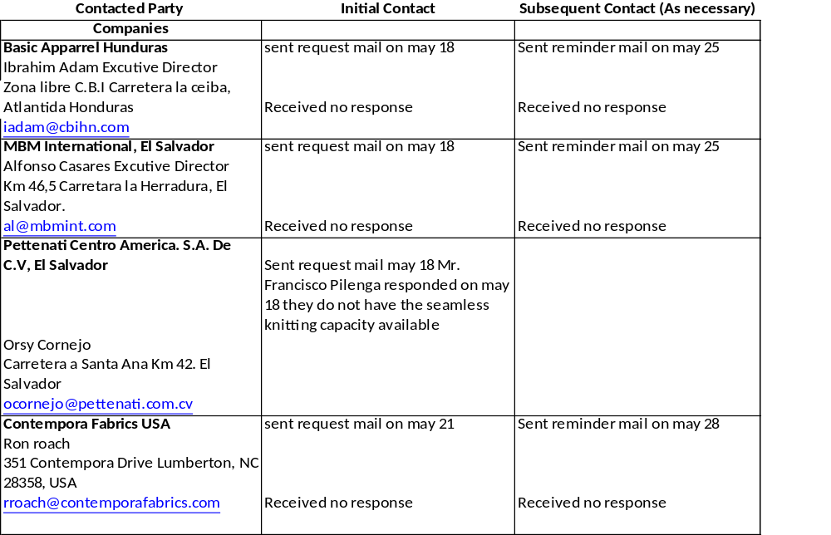

The Honorable, Ms. Glas
June 04, 2012
Page 6

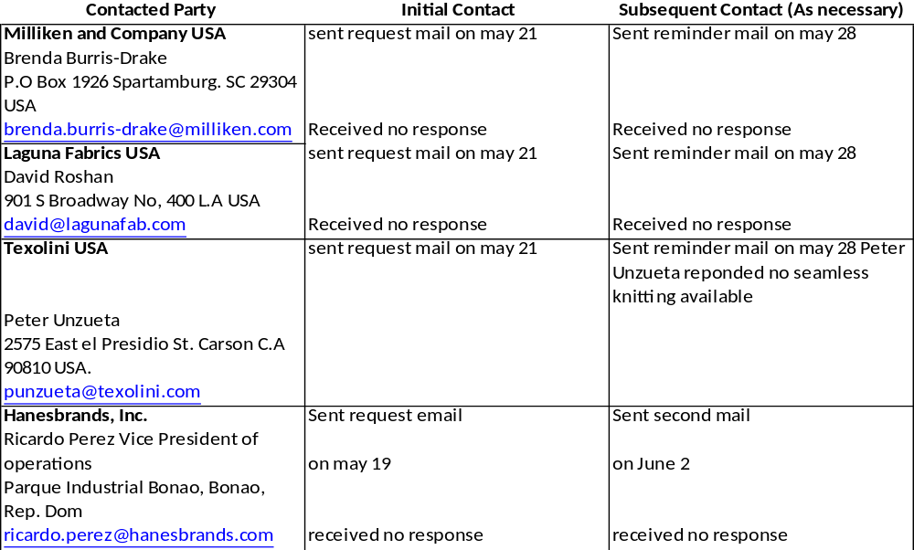

As a result of these inquiries, we are firmly of the conviction that the subject fabrics are not available in
the region. At the conclusion of ten days public comment period and assuming that no objections to this request are received or ability to supply the subject fabric is demonstrated, we would greatly appreciate an expedited
affirmative determination by the Committee.

The Honorable, Ms. Glas
June 04, 2012
Page 7


